Nuclear Power
How it works:
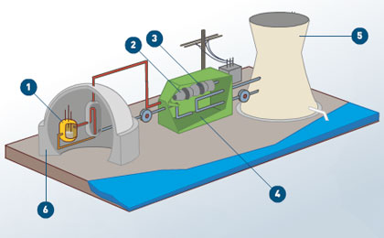
Parts of a nuclear power plant: (interactive https://www.thinglink.com/scene/633021963853365248)
- reactor building which contains the fuel core elements
- turbine
- generator
- turbine building
- cooling towers
- containment structure

Nuclear Energy Explained: How does it work?
https://www.youtube.com/watch?v=rcOFV4y5z8c
Reasons Why Nuclear Energy Is Terrible! (https://www.youtube.com/watch?v=HEYbgyL5n1g)
- nuclear weapons
- nuclear waste
- accidents and disasters

Reasons Why Nuclear Energy Is Awesome! (https://www.youtube.com/watch?v=pVbLlnmxIbY)
- almost no emissions

Temelin, Czech Republic
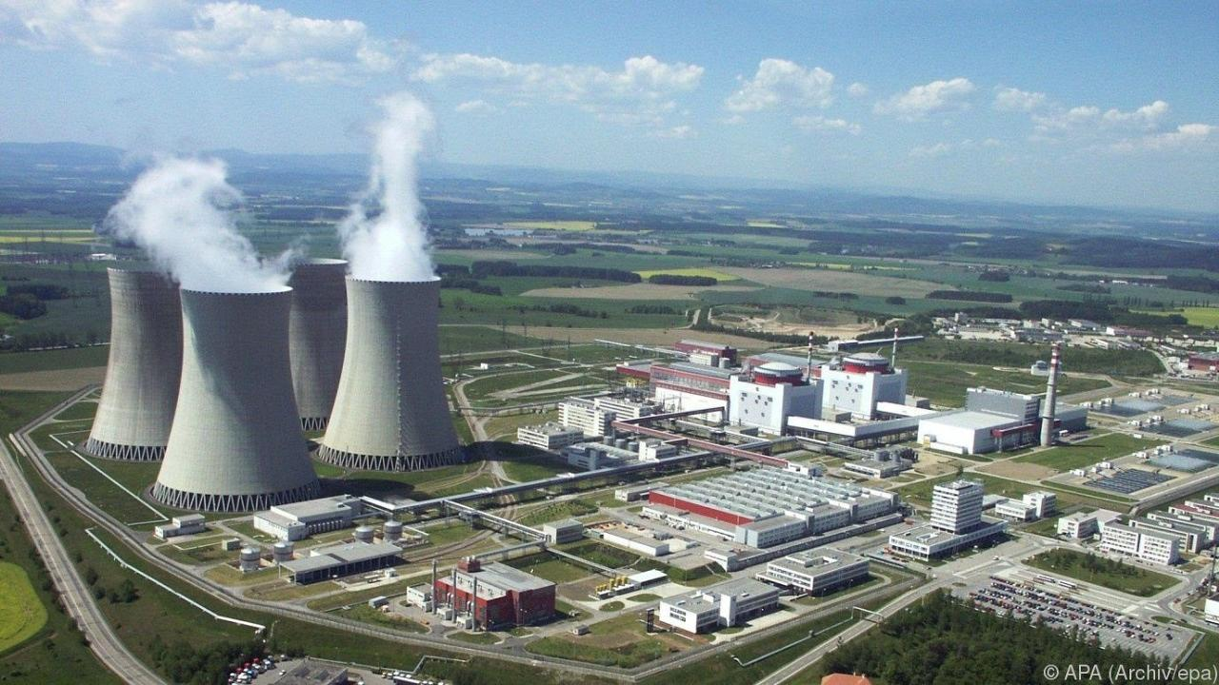
Chernobyl Disaster (How It Happened):
https://www.youtube.com/watch?v=f5ptI6Pi3GA

Article about the sarkophag: https://www.extremetech.com/extreme/240367-30-years-later-1-6b-mega-project-finally-puts-chernobyl-rest

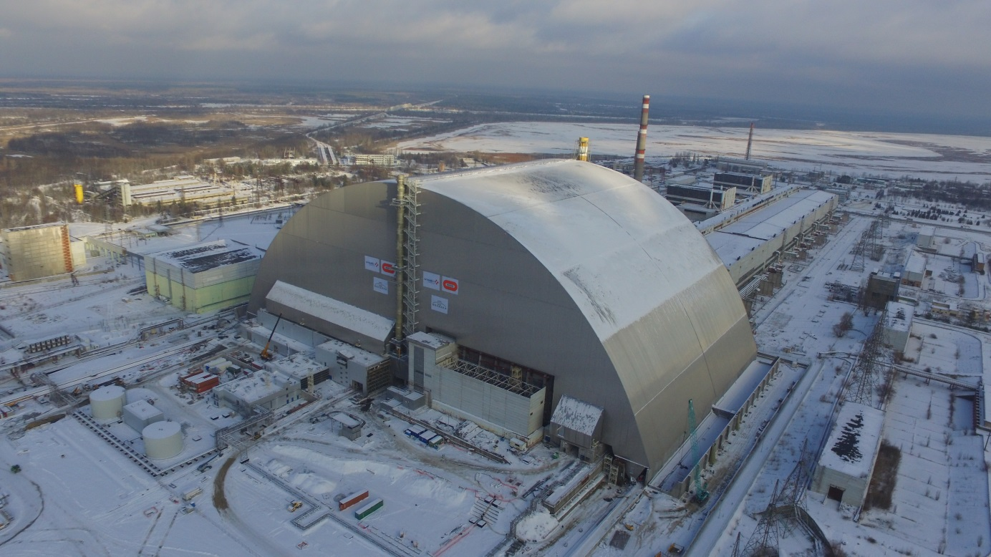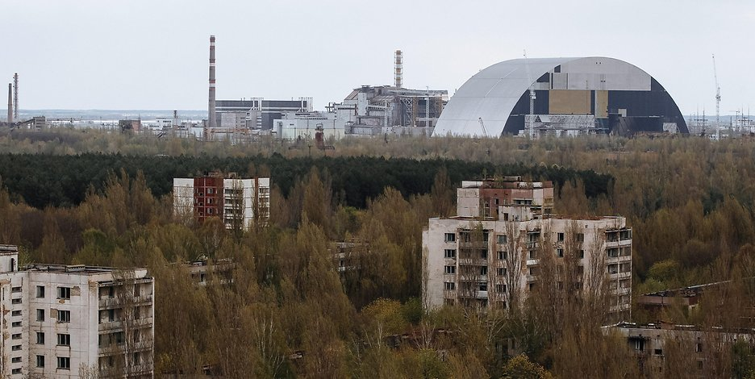
Wikipedia:
https://en.wikipedia.org/wiki/Nuclear_power

